Project Report Template

## 1. INRODUCTION

## 1.1 Overview

* Talent Management

* Job analysis

* Workforce Operation

* Performance measurement

* Incentive programs

* Professional development

### 1.2 purpose

* Organization structure

* Staffing

* Career path

* Learning and Development

* Performance Management

* Policy Governance

# 2. PROBLEM DEFINITION AND DESIGN THINKING

## 2.1 Empathy Map

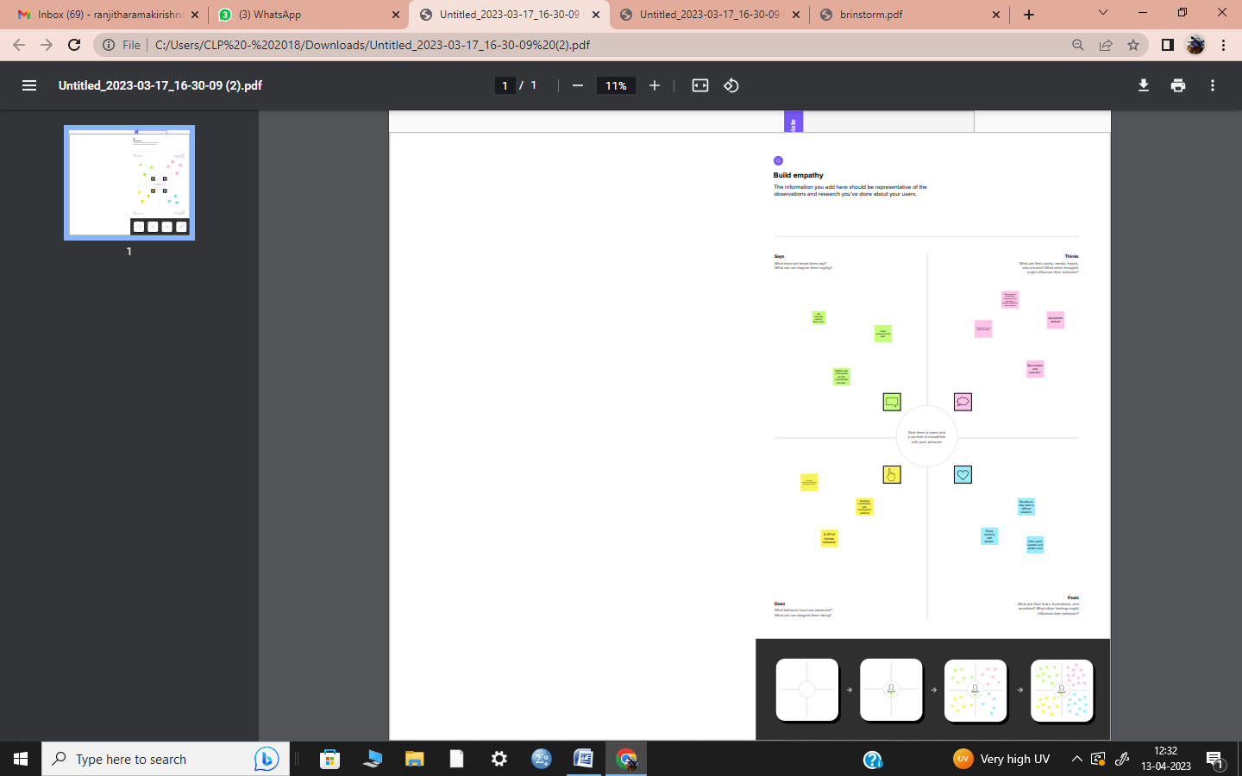

## 2. 2 Ideation and Brainstorming Map

# 

# 3. RESULT

## 3.1 Data Modal:

|  |  |
| --- | --- |
| Object name | Fields in the object |
| JOB POSTING | |  |  | | --- | --- | | Field label | Data type | | Job posting site | Text | | Review | Auto number | |
| FILED & RELATIONSHIP | |  |  | | --- | --- | | Field label | Data type | | Field & Relationship | URL | | Field & Relationship | Master –detail  Relationship | |

## 3.2Activity &Screenshot

#### * Job posting site

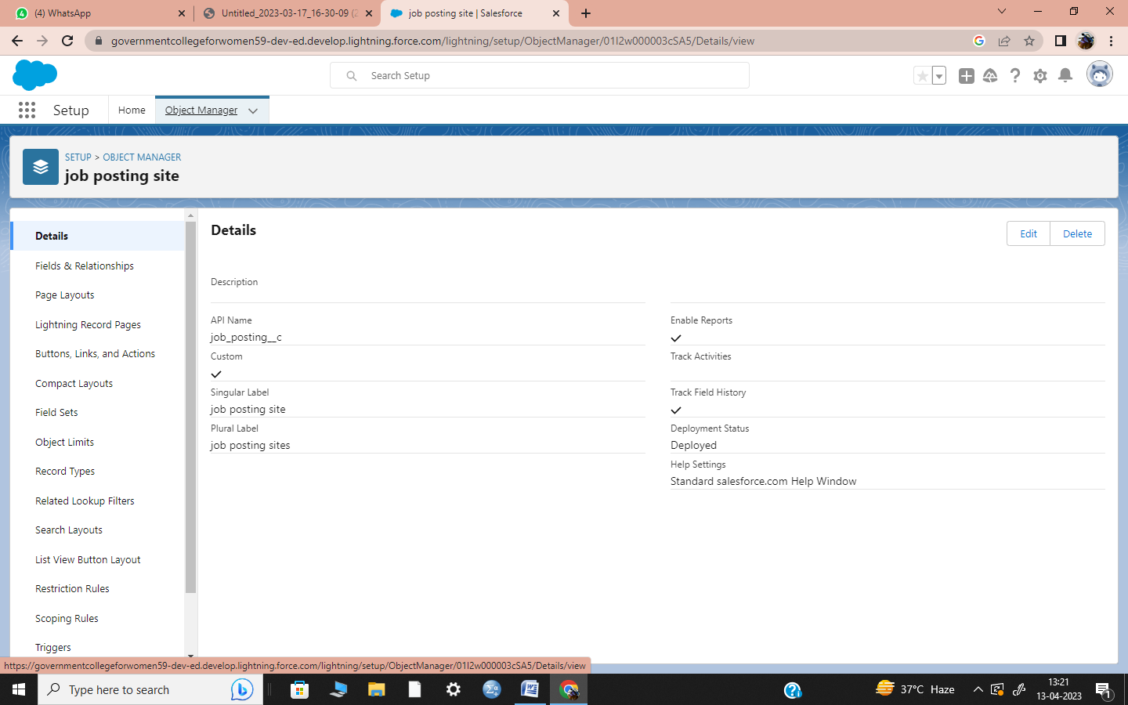

#### *Reviews

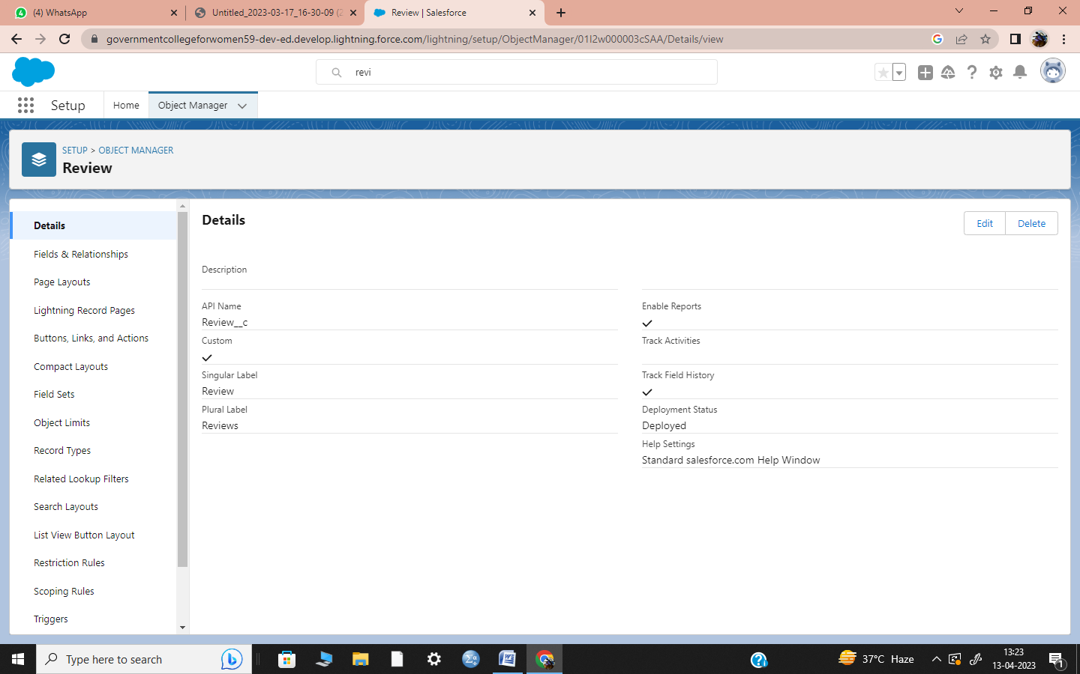

#### *Fields

#### *Status

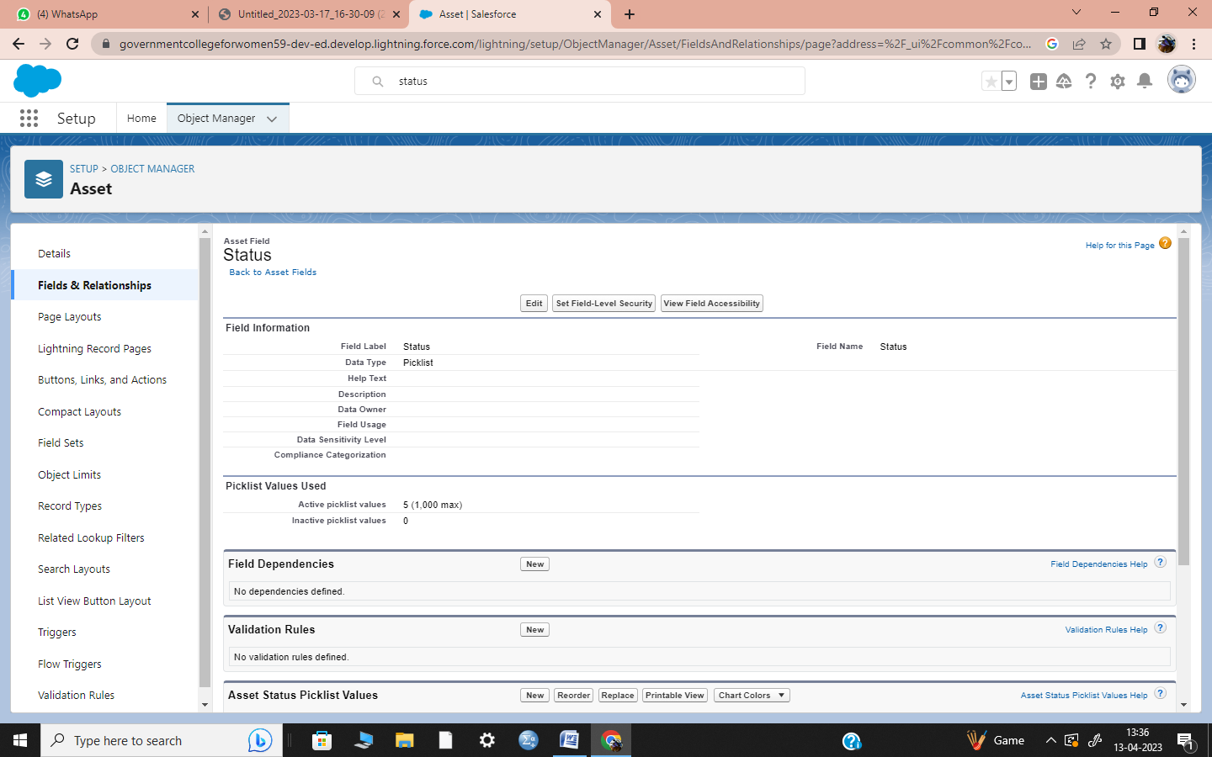

#### *Technical site

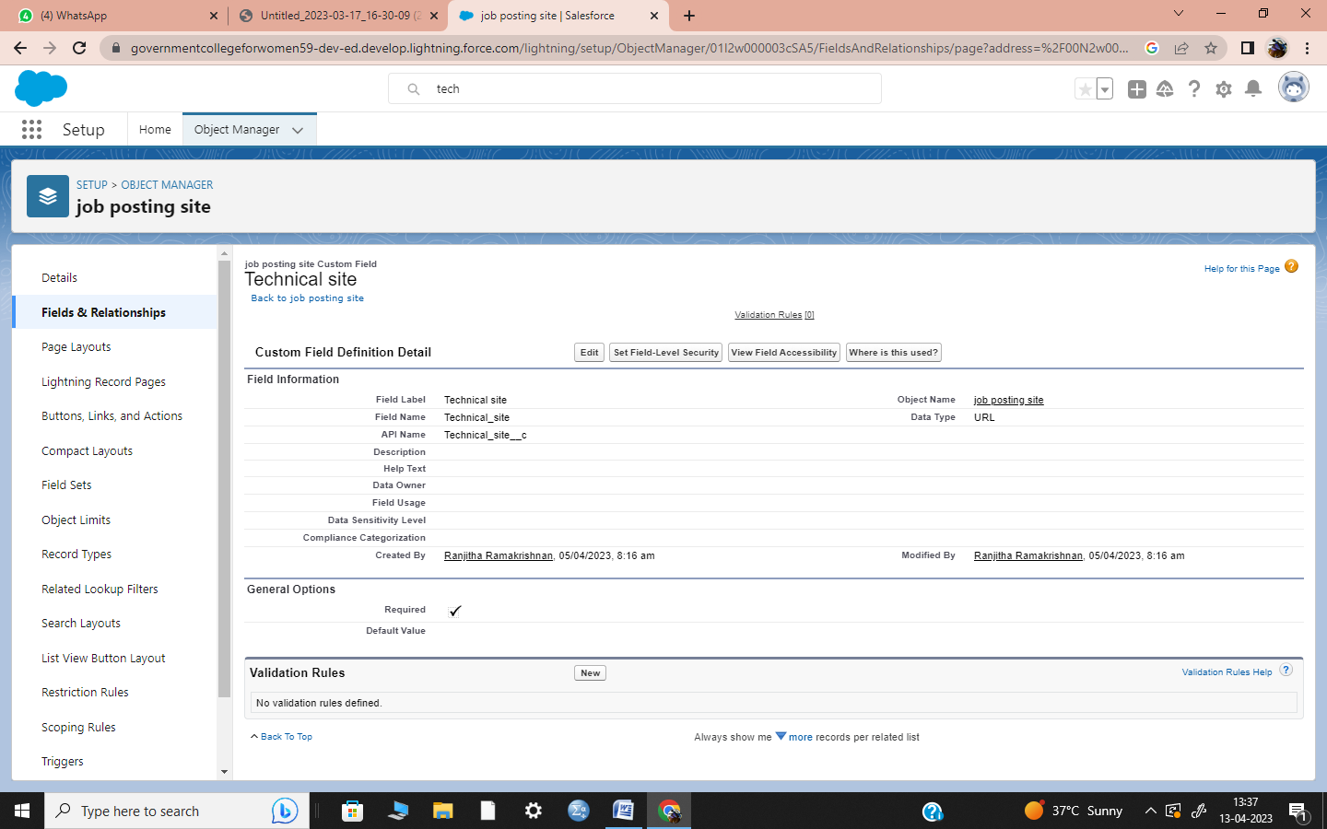

#### *Description

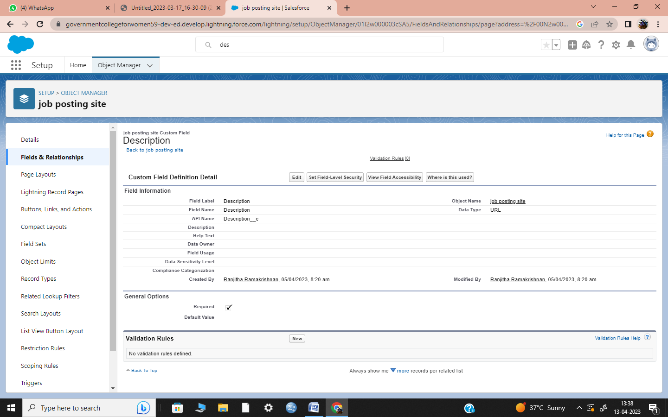

#### *Job posting

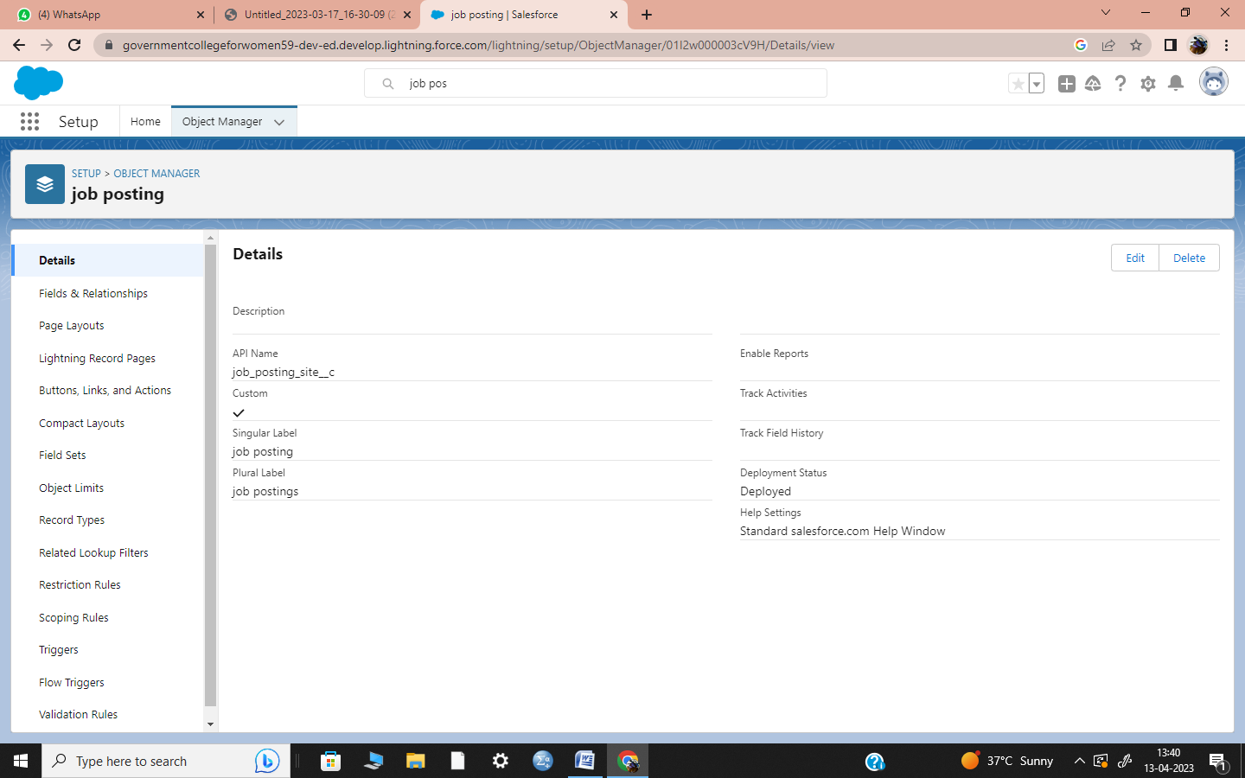

#### *User

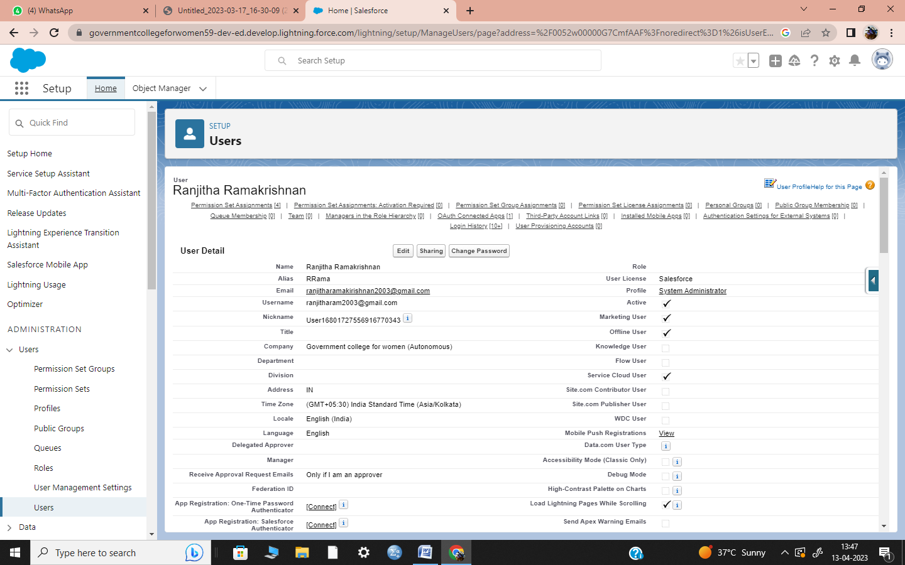

### Trailhead profile public URL

Team lead - <https://trailblazer.me/id/rramakrishna22>

Team Member 1- <https://trailblazer.me/id/sanks37>

Team Member 2- <https://trailblazer.me/id/santr54>

Team Member 3- <https://trailblazer.me/id/sivab60>

# 5. ADVANTAGES & DISADVANTAGES

### * Human Resource Management system require huge costs for installation within the business origination.

### * Owners need to give proper training to its workers for settings up and running these systems.

### * Small business cannot afford to run these systems within their operations.

# 6. APPLICATIONS

## *HRM Application included an employee self-service portal, payroll, workforce management, recruitment and hiring, benefits administration, and talent management.

# 7. CONCLUSION

### * The Human Resource Management plays very significant role in the daily life.

### * In the conclusion of HR management assignment, the final remedy or justification is usually given.

### *The HR life cycle framework has evolved into becoming a strategic tool for any organizations management of human capital.

# 8. FUTURE SCOPE

## * The demand for an HR Professional has even grown rather than going down.

### * Its making the job of HR Professionals particularly difficult.

## * The scope of the MBA in HR is a totally demanding career.